**Project On**

**Restourant**

**Declaration**

We hereby certify that the project entitled “On Line Placement Cell System” by

Ankur Shahi, University Roll No:6250303014 , in partial fulfillment of requirements

for the award of degree of B.Tech submitted in the Department of computer science

at shaheed udham singh engineering and technology(tangori),Mohali, is an authentic

record of our own work carried out under the supervision of Er.Yuvika. The matter presented has not been submitted by me in any other University / Institute for the award of B.Tech. Degree.

I shall be accountable for any misleading information in any part of this report

Signature of candidate

(Ankur Shahi)

**Acknowledgement**

It is a pleasure that we find ourselves penning down these lines to express our sincere thanks to the people who helped us along the way in completing our project. We find inadequate words to express our sincere gratitude towards them.

First and foremost we would like to express our gratitude towards our training guide Ms. Yuvika, for placing complete faith and confidence in our ability to carry out this project and for providing us her time, inspiration, encouragement, help, valuable guidance, constructive criticism and constant interest. He took personal interest in spite of numerous commitments and busy schedule to help us complete this project. Without the sincere and honest guidance of our respected project guide we would have not been to reach the present stage.

We are thankful to Er. Rohini Mahajan (H.O.D, CSE dept) and Ms.Sonal Rana (Project Coordinator) for their support in guiding us and giving us the right direction every time we need.

ANKUR SHAHI(6250303014)

**Abstract**

This is a project report on “**On Line Placement Cell System**”. During the making/developing of this project we explored new ideas and functionality behind the working of a notepad.

This project is the output of our planning, schedule, programming skill and the hard work, and this report reflects our steps taken at various levels of programming skill, planning and schedule.

We have learnt a lot during this project and liked the improvement in our testing skills and deep concept related to these kinds of projects.

Our project is **On Line Placement Cell System**. Thisis a web based application which helps people for placements on internet. It is useful in organizations like colleges, industries or companies and also for finding and applying jobs online.

**Preface**

Learning comes from doing. To learn something one has to go through Practical conditions. Recognizing this fact, the University has made it essential for **Computer Science and Engineering** **(CSE)** students to undergo Industrial Training for six months. During this period, the student learns about the functioning of the organization and the actual business environment. Also this training helps the student how to implement the theoretical knowledge into practical life, in our day to day life. This project report was prepared during the training period in the month of Jan – June.

During this period, an effort was made to understand **On Line Placement System** and to finish the project work assigned to us. This report lays special emphasis on the operational work, tasks and projects carried out during the training period.

**COMPANY PROFILE**

**Introduction Of Company**

**Oops InfoSolutions** was established in **2003.** Its foundation and purpose is to provide and construct programs for existing companies and provide new and exciting updates to primitive basic technologies. Global Career Infotech started in Mohali which is situated in Punjab, India and is one of the first to be opened in the vicinity. Global Career Infotech first started with the education in India, through their curriculum we were able to negotiate a service that was accessible to all students and post Graduates (this continued with great success). We also provide study materials i.e program languages C, C++,Visual C++, VB, VB.Net, ASP.Net, XML, Oracle 9i, Sql Server 2000, ASP, Java, Advance Java, Multimedia(Flash MX,Director MX,Fireworks MX,Dreamweaver Mx). We have now expanded our network to other countries such as England, USA. This has met with much appreciation & support. Global Career Infotech is now entering its 4th successful year. Through networking we are able to provide a service to all races of people.

**Vision**

To be the leader in the industry oriented quality education and training and be the country’s premier institute for certification in the field of information, electronics and communications technology (IECT).

**Mission**

To be the single source for quality assurance in computer education amongst the nation’s institutes.

### 

### OBJECTIVE

1. Encourage and promote the development and progress of electronic Data Processing towards achieving self-reliance in the field of computer sciences and technology for scientific research and development, educational governmental commercial and industrial applications both for indigenous utilization as well as for export.
2. Advance interdisciplinary co-operation amongst scientists, technologists, engineers, administrators and commercial entrepreneurs for the growth of teaching research and practice of Electronic Data Processing Systems and allied subjects in Academic Institutions, Centre and State Govts, Industrial, Commercial and Research and Development Organisations.
3. Disseminate knowledge on all aspects of Electronic Data Processing Systems and allied subjects, and to foster the development of this specialized branch of technology.
4. Stimulate and offer aid for research and development of the benefit of manufactures End users Electronic Data Processing Systems.

**Provide support for software development on consultancy basis**.

Establish, manage and operate sub-Centre’s for all or any of the objectives of the Centre.In pursuit of these objectives, the Centre may engage in the following activities.

1.Setup Advisory and Consultancy Services.

2.Organize study programmers, symposia, conferences, lectures.

3.Maintain contacts with other learned and professional organizations.

4.Support publication activities.

**What we do - Our Core Competencies**

Our full-service portfolio that allows us to address diverse customer needs and deliver an integrated, one-stop solution differentiates us. Our customers work with us across different service lines - using the depth and breadth of our offering to align IT strategy with evolving business needs .

**Consulting and Implementation services** in ERP domain (very specifically in SAP R/3 and Oracle Applications) and advanced Internet technologies i.e. Microsoft .NET, J2EE framework and open source technologies like PHP, MySQL

**Enterprise Application Development** – We are developing Web solutions for complex integration issues between ERP and legacy systems. We are involved in multiple offshore projects for developing Enterprise Applications using Java and .NET technologies. Oops Info Solutions specializes for providing outsourcing solutions for development and maintenance of your non-core business requirements using reliable, secure and agile infrastructure & resources.

**Training in Advanced technologies**: Shortage of skilled manpower prompted us to open Training division to cater to our company needs and for outside world as well. Our training division is providing training in the followings.

• Enterprise Application development using Java

• Enterprise Application development using VB.NET

• Enterprise Application development using VC#. NET

• Website development using PHP and MySQL

• Embedded Programming using Assembly Language and C

**.**  Hardware interfacing development-using VC++. NET .

• OO Programming using Java

• XML

• J2EE Programming

• Introduction to Struts

• . NET framework

• Web services

• ASP.NET

We commit to bringing operational excellence to reengineer business processes for optimal service, quality and cost. Oops Info SolutionsTechnologies currently has development centers in Delhi and Chandigarh. The Oops Info Solutions development centers are state-of-the-art facilities in terms of their infrastructure, data security, and physical location projection. The centers have high-speed data links that connect them with each other and with the clients to create seamless virtually based teams. Since we know security is important, the networks are protected through multiple layers of firewalls and DMZ implementations to ensure our customers' assets are protected

We are involved in development of following products**: -**

* Kerbros Protocol **:-** This isSecure Authentication protocol that ensure the information transfer from on network to another network without hacking . this is anti hacking software.
* **PGP :-** This is also for used to transfer information from one machine to another without any hacking.
* **Messenger:-** allow chatting with one or more clients.
* **Search Engine**:- Allow searching of information on the internet.
  1. • **Project tracker:** Project Tracker is a web-based solution to track time and expenses for consultants working on different client sites and on different projects. It is also used for doing project costing for consultants: employees and/or subcontractors, qualification management, Budgeting and Real time reporting

• **Shipping Manager:** Web based communication between ERP and non ERP systems

* 1. **• Document Management System:** The system helps in scanning, optical character recognition (OCR), and indexing of between 2 million and 12 million pages of tobacco industry documents. The system then helps in document search, retrieval, indexing, workflow management and distribution.
  2. • **Management Information System:** The Management Information System (MIS) is a comprehensive and integrated software solution designed by to cater to the varied IT requirements of organizations. The solution offers services for complete automation of organization’s functioning, as well as, web based comprehensive communication solution for organization, wherein; the staff members, shareholders of the organization are connected online for increased communication between them.
  3. • **Enterprise Resource Planning (ERP) System:** The ERP system would cater to the requirements in the area of Sales, order and invoicing, production planning, production, inventory, purchase, finance, personnel and payroll management.
  4. **• Online Reservation System:** Online reservation system for Hotels, Resorts, Motels, Villas, Apartments, Bed and Breakfasts, Guest Houses ...etc. of any size.

• **Web base Requirements/Resume Tracking System**: The system tracks the staffing requirements of numerous customers, searches a database for potential candidates, and monitor the interviewing and hiring process from beginning till end.

* **Blog Site : -** This site allow on line users to send the comments on the specific topics. The other users can send reply to the comments. Managements can view the overall comments and reply to different blogs.
* **University Management** :- Manages the Universities to track the information on line of different universities and colleges.

1. ***Introduction:***

This project is on Restaurant. This is an online web application which is make in MEAN stack technology. ON THIS project first customer make registration , then generate usrname nd password to customer.

Customer can check dialy menu like Butter ticka, Tandoori roti, chicken etc.

He will select the Full plate and Half plate and then he will place order to restaurant and then manager or admin of restaurant confirm the order and then he will pay online via visa card, master card etc.

This is an comptrized system which will help the administration and also help customers to save time and money also.

Because on online transaction hotel provides discout coupans also

**Two Modules in Project**

1 Admin

2 Customer

**Tasks of Admin**

Following tasks are

Admin can add,delete,modify users

Admin can manage Menu

Admin can manage database

Manage customers

Manage requests for customers

**Tasks of customers**

Edit profile

View hotel Menu

Place order for dish

Payment online

**Hardware and Software Requirements**

**Softwares:**

**Operating System Server:** Windows XP /Linux/Mac/Unix etc.

**Database Server:** wampserver

**Client:** Microsoft Internet Explorer,Chrome

**Tools** HTML,CSS,JAVASCRIPT,angularjs,expressjs,nodejs

**Hardware Specification:**

**Processor:** Intel Pentium or More

**RAM:** 1gb RAM

**Hard Disk:** PC with 20GB

HTML

html(hyper text markup language)

which execute the code without compilation with help of inbuild tag

html is not any programing language like c and c+. IT IS BASic language i.e it has no any compiler,it has only interpreter.(browser ie,friefox)(html,dhtml,xml,javascript)

it is static language i.e not change at run time

it is used for web designing i.e how to design front page of the website.

we use predefined tags <html>

tag:- a tag is spcified and bounded area which is used to perfrom any spcific task and already encode into any browser library known as tag.<table><button>---browser

html5--version

90 tags

2 type of tag

1 paired tag <html> </html>

2 unpaired tag <br><hr><input><img><link>

we call html as markup language becuase we use markup tags i.e inbuild tag so we call it markup language

.html

Javascript

javascript:-

javascript is used to make the page dynamic. javascript is used to add form validation. it makes the execution fast.

it works on client side.

we use inbuild functions,events and object in javascript to perfrom any action on the html elements.

event:- these are inbuild actions which called automaticaly and may change the internal state of any source are known as event.d

event source:- the sources which generates an event are known as event source.

for example button,window,mouse,keyboard

there are 18 event in javascript

1 onclick

2 ondblclick

3 onmouseover

4 onmouseout

5 onmousedown

6 onmouseup

7 onfocus

8 onchange

9 onsubmit

10 onreset

11 onkeyup

12 onkeydown

13 onblur

14 onerror

15 oNresize

16 onselect

17 onload

18 onunload

we use inbuild functions like

alert()

confirm()

prompt()

Date()

toUpperCase()

toLowerCase()

Math.random()

Math.round()

getHours()

getMinutes()

getSeconds()

setTimeout()

moveBy()

indexOf()

open()

close()

document.write()

document.getElementById()

we use inbuild objects like

document

window

location

navigator

event

Css(Cacading stylesheet)

css(cascading stylesheet)

css is used to make advanced tools of designing on the html tags like <p><div><button> <table> etc.

css are of three type

1 external

2 internal stylesheet

3 inline css

1 in external stylesheet we give styles to tags in .css file and link the .css file with html page by using following tag on html page

<link rel=stylesheet href="aa.css">

we can link one .css file with more than one html page

it avoides reptition of code

it reduces complxity of code

2 in internal stylesheet we give styles to tags on same html page by using following tag

on html page

<style>

---css---

</style>--

--tags--

no need to make .css file

3 in inline css we give styles to tags in single line by using following tag

tagname:attributename{parameters}

it may be part of external as well as internal stylesheet

AngularJS is a JavaScript Framework

AngularJS is a JavaScript framework. It is a library written in JavaScript.

AngularJS is distributed as a JavaScript file, and can be added to a web page with a script tag:-

Angular 1 release in 2012

-----------------------------------

A complete client-side solution

Angular is not a single piece in the overall puzzle of building the client-side of a web application. It handles all of the DOM and AJAX glue code you once wrote by hand and puts it in a well-defined structure. This makes Angular opinionated about how a CRUD (Create, Read, Update, Delete) application should be built. But while it is opinionated, it also tries to make sure that its opinion is just a starting point you can easily change. Angular comes with the following out-of-the-box:

Everything you need to build a CRUD app in a cohesive set: Data-binding, basic templating directives, form validation, routing, deep-linking, reusable components and dependency injection.

Testability story: Unit-testing, end-to-end testing, mocks and test harnesses.

Seed application with directory layout and test scripts as a starting point.

----------------------------------------------

------

AngularJS extends HTML with ng-directives.

The ng-app directive defines an AngularJS application.

The ng-model directive binds the value of HTML controls (input, select, textarea) to application data.

The ng-bind directive binds application data to the HTML view.

The ng-init directive initializes AngularJS application variables.

1 forms

2 scopes

3 modules

4 ajax

5 upload/login/register/delete modeidy

6 filters--> to change the data format-- uppercase,lowercase ,currency fileter, oredrby

7 Dom--- ng-show,ng-click to bind data with html elements

8 Services

----------------------------------------

Scope is a special javascript object which plays the role of joining controller with the views. Scope contains the model data. In controllers, model data is accessed via $scope object.

-------------------------------------

Custom directives are used in AngularJS to extend the

-------------------------

functionality of HTML. Custom directives are defined using "directive" function. A custom directive simply replaces the element for which it is activated. AngularJS application during bootstrap finds the matching elements and do one time activity using its compile() method of the custom directive then process the element using link() method of the custom directive based on the scope of the directive. AngularJ

--------------------

AngularJS supports inbuilt internationalization for three types of filters currency, date and numbers. We only need to incorporate corresponding js according to locale of the country.

---------------------------------

applications:---

we can easily devlope

Search Tab

Map

Chart Application

Nav Menu

Swicth menu application

Whather Applications etc.

Notepad

Bootstrap:-

What is Bootstrap?

Bootstrap is a free front-end framework for faster and easier web development

Bootstrap includes HTML and CSS based design templates for typography, forms, buttons, tables, navigation, modals, image carousels and many other, as well as optional JavaScript plugins

Bootstrap also gives you the ability to easily create responsive designs

What is Responsive Web Design?

Responsive web design is about creating web sites which automatically adjust themselves to look good on all devices, from small phones to large desktops.

1. Add the HTML5 doctype

Bootstrap uses HTML elements and CSS properties that require the HTML5 doctype.

Always include the HTML5 doctype at the beginning of the page, along with the lang attribute and the correct character set:

Containers

Bootstrap also requires a containing element to wrap site contents.

There are two container classes to choose from:

The .container class provides a responsive fixed width container

The .container-fluid class provides a full width container, spanning the entire width of the viewport

<!DOCTYPE html>

<html lang="en">

<head>

<meta charset="utf-8">

</head>

</html>

Bootstrap's grid system is responsive, and the columns will re-arrange automatically depending on the screen size.

Grid Classes

The Bootstrap grid system has four classes:

xs (for phones)

sm (for tablets)

md (for desktops)

lg (for larger desktops)

Nodejs

Node.js is a very powerful JavaScript-based framework/platform built on Google Chrome's JavaScript V8 Engine. It is used to develop I/O intensive web applications like video streaming sites, single-page applications, and other web applications. Node.js is open source, completely free, and used by thousands of developers around the world.

------------------------

Node.js is a server-side platform built on Google Chrome's JavaScript Engine

---

Node.js is an open source, cross-platform runtime environment for developing server-side and networking applications. Node.js applications are written in JavaScript, and can be run within the Node.js runtime on OS X, Microsoft Windows, and Linux.

Node.js also provides a rich library of various JavaScript modules which simplifies the development of web applications using Node.js to a great extent.

--------------

features

1 Asynchronous and Event Driven

2 Very Fast

3 Single Threaded but Highly Scalable

4 No Buffering

5 License

----------------------

Where to Use Node.js?

Following are the areas where Node.js is proving itself as a perfect technology partner.

I/O bound Applications

Data Streaming Applications

Data Intensive Real-time Applications (DIRT)

JSON APIs based Applications

Single Page Applications

operators use in nodejs

Assignment operators

Comparison operators

Arithmetic operators

Bitwise operators

Logical operators

String operators

Conditional (ternary) operator

Comma operator

Unary operators

Relational operator Assignment operators

An [assignment operator](https://developer.mozilla.org/en-US/docs/Web/JavaScript/Reference/Operators/Assignment_Operators) assigns a value to its left operand based on the value of its right operand. The simple assignment operator is equal (=), which assigns the value of its right operand to its left operand. That is, x = y assigns the value of y to x.

There are also compound assignment operators that are shorthand for the operations listed in the following table:

| **Compound assignment operators** | | |
| --- | --- | --- |
| **Name** | **Shorthand operator** | **Meaning** |
| [Assignment](https://developer.mozilla.org/en-US/docs/Web/JavaScript/Reference/Operators/Assignment_Operators#Assignment) | x = y | x = y |
| [Addition assignment](https://developer.mozilla.org/en-US/docs/Web/JavaScript/Reference/Operators/Assignment_Operators#Addition_assignment) | x += y | x = x + y |
| [Subtraction assignment](https://developer.mozilla.org/en-US/docs/Web/JavaScript/Reference/Operators/Assignment_Operators#Subtraction_assignment) | x -= y | x = x - y |
| [Multiplication assignment](https://developer.mozilla.org/en-US/docs/Web/JavaScript/Reference/Operators/Assignment_Operators#Multiplication_assignment) | x *= y | x = x * y |
| [Division assignment](https://developer.mozilla.org/en-US/docs/Web/JavaScript/Reference/Operators/Assignment_Operators#Division_assignment) | x /= y | x = x / y |
| [Remainder assignment](https://developer.mozilla.org/en-US/docs/Web/JavaScript/Reference/Operators/Assignment_Operators#Remainder_assignment) | x %= y | x = x % y |
| [Exponentiation assignment](https://developer.mozilla.org/en-US/docs/Web/JavaScript/Reference/Operators/Assignment_Operators#Exponentiation_assignment) | x **= y | x = x ** y |
| [Left shift assignment](https://developer.mozilla.org/en-US/docs/Web/JavaScript/Reference/Operators/Assignment_Operators#Left_shift_assignment) | x <<= y | x = x << y |
| [Right shift assignment](https://developer.mozilla.org/en-US/docs/Web/JavaScript/Reference/Operators/Assignment_Operators#Right_shift_assignment) | x >>= y | x = x >> y |
| [Unsigned right shift assignment](https://developer.mozilla.org/en-US/docs/Web/JavaScript/Reference/Operators/Assignment_Operators#Unsigned_right_shift_assignment) | x >>>= y | x = x >>> y |
| [Bitwise AND assignment](https://developer.mozilla.org/en-US/docs/Web/JavaScript/Reference/Operators/Assignment_Operators#Bitwise_AND_assignment) | x &= y | x = x & y |
| [Bitwise XOR assignment](https://developer.mozilla.org/en-US/docs/Web/JavaScript/Reference/Operators/Assignment_Operators#Bitwise_XOR_assignment) | x ^= y | x = x ^ y |
| [Bitwise OR assignment](https://developer.mozilla.org/en-US/docs/Web/JavaScript/Reference/Operators/Assignment_Operators#Bitwise_OR_assignment) | x |= y | x = x | y |

| **Comparison operators** | | |
| --- | --- | --- |
| **Operator** | **Description** | **Examples returning true** |
| [Equal](https://developer.mozilla.org/en-US/docs/Web/JavaScript/Reference/Operators/Comparison_Operators#Equality) (==) | Returns true if the operands are equal. | 3 == var1  "3" == var1  3 == '3' |
| [Not equal](https://developer.mozilla.org/en-US/docs/Web/JavaScript/Reference/Operators/Comparison_Operators#Inequality)(!=) | Returns true if the operands are not equal. | var1 != 4 var2 != "3" |
| [Strict equal](https://developer.mozilla.org/en-US/docs/Web/JavaScript/Reference/Operators/Comparison_Operators#Identity)(===) | Returns true if the operands are equal and of the same type. See also [Object.is](https://developer.mozilla.org/en-US/docs/Web/JavaScript/Reference/Global_Objects/Object/is) and [sameness in JS](https://developer.mozilla.org/en-US/docs/Web/JavaScript/Equality_comparisons_and_sameness). | 3 === var1 |
| [Strict not equal](https://developer.mozilla.org/en-US/docs/Web/JavaScript/Reference/Operators/Comparison_Operators#Nonidentity) (!==) | Returns true if the operands are of the same type but not equal, or are of different type. | var1 !== "3" 3 !== '3' |
| [Greater than](https://developer.mozilla.org/en-US/docs/Web/JavaScript/Reference/Operators/Comparison_Operators#Greater_than_operator)(>) | Returns true if the left operand is greater than the right operand. | var2 > var1 "12" > 2 |
| [Greater than or equal](https://developer.mozilla.org/en-US/docs/Web/JavaScript/Reference/Operators/Comparison_Operators#Greater_than_or_equal_operator) (>=) | Returns true if the left operand is greater than or equal to the right operand. | var2 >= var1 var1 >= 3 |
| [Less than](https://developer.mozilla.org/en-US/docs/Web/JavaScript/Reference/Operators/Comparison_Operators#Less_than_operator) (<) | Returns true if the left operand is less than the right operand. | var1 < var2 "2" < 12 |
| [Less than or equal](https://developer.mozilla.org/en-US/docs/Web/JavaScript/Reference/Operators/Comparison_Operators#Less_than_or_equal_operator) (<=) | Returns true if the left operand is less than or equal to the right operand. | var1 <= var2 var2 <= 5 |

### Bitwise operators

A [bitwise operator](https://developer.mozilla.org/en-US/docs/Web/JavaScript/Reference/Operators/Bitwise_Operators) treats their operands as a set of 32 bits (zeros and ones), rather than as decimal, hexadecimal, or octal numbers. For example, the decimal number nine has a binary representation of 1001. Bitwise operators perform their operations on such binary representations, but they return standard JavaScript numerical values.

The following table summarizes JavaScript's bitwise operators.

| **Bitwise operators** | | |
| --- | --- | --- |
| **Operator** | **Usage** | **Description** |
| [Bitwise AND](https://developer.mozilla.org/en-US/docs/Web/JavaScript/Reference/Operators/Bitwise_Operators#Bitwise_AND) | a & b | Returns a one in each bit position for which the corresponding bits of both operands are ones. |
| [Bitwise OR](https://developer.mozilla.org/en-US/docs/Web/JavaScript/Reference/Operators/Bitwise_Operators#Bitwise_OR) | a | b | Returns a zero in each bit position for which the corresponding bits of both operands are zeros. |
| [Bitwise XOR](https://developer.mozilla.org/en-US/docs/Web/JavaScript/Reference/Operators/Bitwise_Operators#Bitwise_XOR) | a ^ b | Returns a zero in each bit position for which the corresponding bits are the same. [Returns a one in each bit position for which the corresponding bits are different.] |
| [Bitwise NOT](https://developer.mozilla.org/en-US/docs/Web/JavaScript/Reference/Operators/Bitwise_Operators#Bitwise_NOT) | ~ a | Inverts the bits of its operand. |
| [Left shift](https://developer.mozilla.org/en-US/docs/Web/JavaScript/Reference/Operators/Bitwise_Operators#Left_shift) | a << b | Shifts a in binary representation b bits to the left, shifting in zeros from the right. |
| [Sign-propagating right shift](https://developer.mozilla.org/en-US/docs/Web/JavaScript/Reference/Operators/Bitwise_Operators#Right_shift) | a >> b | Shifts a in binary representation b bits to the right, discarding bits shifted off. |
| [Zero-fill right shift](https://developer.mozilla.org/en-US/docs/Web/JavaScript/Reference/Operators/Bitwise_Operators#Unsigned_right_shift) | a >>> b | Shifts a in binary representation b bits to the right, discarding bits shifted off, and shifting in zeros from the left. |

#### Bitwise logical operators

Conceptually, the bitwise logical operators work as follows:

* The operands are converted to thirty-two-bit integers and expressed by a series of bits (zeros and ones). Numbers with more than 32 bits get their most significant bits discarded. For example, the following integer with more than 32 bits will be converted to a 32 bit integer:
* Before: 11100110111110100000000000000110000000000001

After: 10100000000000000110000000000001

* Each bit in the first operand is paired with the corresponding bit in the second operand: first bit to first bit, second bit to second bit, and so on.
* The operator is applied to each pair of bits, and the result is constructed bitwise.

For example, the binary representation of nine is 1001, and the binary representation of fifteen is 1111. So, when the bitwise operators are applied to these values, the results are as follows:

| **Bitwise operator examples** | | |
| --- | --- | --- |
| **Expression** | **Result** | **Binary Description** |
| 15 & 9 | 9 | 1111 & 1001 = 1001 |
| 15 | 9 | 15 | 1111 | 1001 = 1111 |
| 15 ^ 9 | 6 | 1111 ^ 1001 = 0110 |
| ~15 | -16 | ~00000000...00001111 = 11111111...11110000 |
| ~9 | -10 | ~00000000...00001001 = 11111111...11110110 |

Note that all 32 bits are inverted using the Bitwise NOT operator, and that values with the most significant (left-most) bit set to 1 represent negative numbers (two's-complement representation).

#### Bitwise shift operators

The bitwise shift operators take two operands: the first is a quantity to be shifted, and the second specifies the number of bit positions by which the first operand is to be shifted. The direction of the shift operation is controlled by the operator used.

Shift operators convert their operands to thirty-two-bit integers and return a result of the same type as the left operand.

The shift operators are listed in the following table.

| **Bitwise shift operators** | | |
| --- | --- | --- |
| **Operator** | **Description** | **Example** |
| [Left shift](https://developer.mozilla.org/en-US/docs/Web/JavaScript/Reference/Operators/Bitwise_Operators#<<_(Left_shift)) (<<) | This operator shifts the first operand the specified number of bits to the left. Excess bits shifted off to the left are discarded. Zero bits are shifted in from the right. | 9<<2 yields 36, because 1001 shifted 2 bits to the left becomes 100100, which is 36. |
| [Sign-propagating right shift](https://developer.mozilla.org/en-US/docs/Web/JavaScript/Reference/Operators/Bitwise_Operators#>>_(Sign-propagating_right_shift))(>>) | This operator shifts the first operand the specified number of bits to the right. Excess bits shifted off to the right are discarded. Copies of the leftmost bit are shifted in from the left. | 9>>2 yields 2, because 1001 shifted 2 bits to the right becomes 10, which is 2. Likewise, -9>>2 yields -3, because the sign is preserved. |
| [Zero-fill right shift](https://developer.mozilla.org/en-US/docs/Web/JavaScript/Reference/Operators/Bitwise_Operators#>>>_(Zero-fill_right_shift))(>>>) | This operator shifts the first operand the specified number of bits to the right. Excess bits shifted off to the right are discarded. Zero bits are shifted in from the left. | 19>>>2 yields 4, because 10011 shifted 2 bits to the right becomes 100, which is 4. For non-negative numbers, zero-fill right shift and sign-propagating right shift yield the same result. |

### Logical operators

[Logical operators](https://developer.mozilla.org/en-US/docs/Web/JavaScript/Reference/Operators/Logical_Operators) are typically used with Boolean (logical) values; when they are, they return a Boolean value. However, the && and || operators actually return the value of one of the specified operands, so if these operators are used with non-Boolean values, they may return a non-Boolean value. The logical operators are described in the following table.

| **Logical operators** | | |
| --- | --- | --- |
| **Operator** | **Usage** | **Description** |
| [Logical AND](https://developer.mozilla.org/en-US/docs/Web/JavaScript/Reference/Operators/Logical_Operators#Logical_AND)(&&) | expr1 && expr2 | Returns expr1 if it can be converted to false; otherwise, returns expr2. Thus, when used with Boolean values, && returns true if both operands are true; otherwise, returns false. |
| [Logical OR](https://developer.mozilla.org/en-US/docs/Web/JavaScript/Reference/Operators/Logical_Operators#Logical_OR)(||) | expr1 || expr2 | Returns expr1 if it can be converted to true; otherwise, returns expr2. Thus, when used with Boolean values, || returns true if either operand is true; if both are false, returns false. |
| [Logical NOT](https://developer.mozilla.org/en-US/docs/Web/JavaScript/Reference/Operators/Logical_Operators#Logical_NOT)(!) | !expr | Returns false if its single operand can be converted to true; otherwise, returns true. |

Examples of expressions that can be converted to false are those that evaluate to null, 0, NaN, the empty string (""), or undefined.

The following code shows examples of the && (logical AND) operator.

var a1 = true && true; // t && t returns true

var a2 = true && false; // t && f returns false

var a3 = false && true; // f && t returns false

var a4 = false && (3 == 4); // f && f returns false

var a5 = "Cat" && "Dog"; // t && t returns Dog

var a6 = false && "Cat"; // f && t returns false

var a7 = "Cat" && false; // t && f returns false

The following code shows examples of the || (logical OR) operator.

var o1 = true || true; // t || t returns true

var o2 = false || true; // f || t returns true

var o3 = true || false; // t || f returns true

var o4 = false || (3 == 4); // f || f returns false

var o5 = "Cat" || "Dog"; // t || t returns Cat

var o6 = false || "Cat"; // f || t returns Cat

var o7 = "Cat" || false; // t || f returns Cat

The following code shows examples of the ! (logical NOT) operator.

var n1 = !true; // !t returns false

var n2 = !false; // !f returns true

var n3 = !"Cat"; // !t returns false

#### Short-circuit evaluation

As logical expressions are evaluated left to right, they are tested for possible "short-circuit" evaluation using the following rules:

* false && anything is short-circuit evaluated to false.
* true || anything is short-circuit evaluated to true.

The rules of logic guarantee that these evaluations are always correct. Note that the anythingpart of the above expressions is not evaluated, so any side effects of doing so do not take effect.

### String operators

In addition to the comparison operators, which can be used on string values, the concatenation operator (+) concatenates two string values together, returning another string that is the union of the two operand strings.

For example,

console.log("my " + "string"); // console logs the string "my string".

The shorthand assignment operator += can also be used to concatenate strings.

For example,

var mystring = "alpha";

mystring += "bet"; // evaluates to "alphabet" and assigns this value to mystring.

### Conditional (ternary) operator

The [conditional operator](https://developer.mozilla.org/en-US/docs/Web/JavaScript/Reference/Operators/Conditional_Operator) is the only JavaScript operator that takes three operands. The operator can have one of two values based on a condition. The syntax is:

condition ? val1 : val2

If condition is true, the operator has the value of val1. Otherwise it has the value of val2. You can use the conditional operator anywhere you would use a standard operator.

For example,

var status = (age >= 18) ? "adult" : "minor";

This statement assigns the value "adult" to the variable status if age is eighteen or more. Otherwise, it assigns the value "minor" to status.

### Comma operator

The [comma operator](https://developer.mozilla.org/en-US/docs/Web/JavaScript/Reference/Operators/Comma_Operator) (,) simply evaluates both of its operands and returns the value of the last operand. This operator is primarily used inside a for loop, to allow multiple variables to be updated each time through the loop.

For example, if a is a 2-dimensional array with 10 elements on a side, the following code uses the comma operator to update two variables at once. The code prints the values of the diagonal elements in the array:

for (var i = 0, j = 9; i <= j; i++, j--)

console.log("a[" + i + "][" + j + "]= " + a[i][j]);

### Unary operators

A unary operation is an operation with only one operand.

#### delete

The [delete](https://developer.mozilla.org/en-US/docs/Web/JavaScript/Reference/Operators/delete) operator deletes an object, an object's property, or an element at a specified index in an array. The syntax is:

delete objectName;

delete objectName.property;

delete objectName[index];

delete property; // legal only within a with statement

where objectName is the name of an object, property is an existing property, and index is an integer representing the location of an element in an array.

The fourth form is legal only within a [with](https://developer.mozilla.org/en-US/docs/Web/JavaScript/Reference/Statements/with) statement, to delete a property from an object.

You can use the delete operator to delete variables declared implicitly but not those declared with the var statement.

If the delete operator succeeds, it sets the property or element to undefined. The deleteoperator returns true if the operation is possible; it returns false if the operation is not possible.

x = 42;

var y = 43;

myobj = new Number();

myobj.h = 4; // create property h

delete x; // returns true (can delete if declared implicitly)

delete y; // returns false (cannot delete if declared with var)

delete Math.PI; // returns false (cannot delete predefined properties)

delete myobj.h; // returns true (can delete user-defined properties)

delete myobj; // returns true (can delete if declared implicitly)

##### Deleting array elements

When you delete an array element, the array length is not affected. For example, if you delete a[3], a[4] is still a[4] and a[3] is undefined.

When the delete operator removes an array element, that element is no longer in the array. In the following example, trees[3] is removed with delete. However, trees[3] is still addressable and returns undefined.

var trees = ["redwood", "bay", "cedar", "oak", "maple"];

delete trees[3];

if (3 in trees) {

// this does not get executed

}

If you want an array element to exist but have an undefined value, use the undefined keyword instead of the delete operator. In the following example, trees[3] is assigned the value undefined, but the array element still exists:

var trees = ["redwood", "bay", "cedar", "oak", "maple"];

trees[3] = undefined;

if (3 in trees) {

// this gets executed

}

#### typeof

The [typeof operator](https://developer.mozilla.org/en-US/docs/Web/JavaScript/Reference/Operators/typeof) is used in either of the following ways:

typeof operand

typeof (operand)

The typeof operator returns a string indicating the type of the unevaluated operand. operand is the string, variable, keyword, or object for which the type is to be returned. The parentheses are optional.

Suppose you define the following variables:

var myFun = new Function("5 + 2");

var shape = "round";

var size = 1;

var today = new Date();

The typeof operator returns the following results for these variables:

typeof myFun; // returns "function"

typeof shape; // returns "string"

typeof size; // returns "number"

typeof today; // returns "object"

typeof doesntExist; // returns "undefined"

For the keywords true and null, the typeof operator returns the following results:

typeof true; // returns "boolean"

typeof null; // returns "object"

For a number or string, the typeof operator returns the following results:

typeof 62; // returns "number"

typeof 'Hello world'; // returns "string"

For property values, the typeof operator returns the type of value the property contains:

typeof document.lastModified; // returns "string"

typeof window.length; // returns "number"

typeof Math.LN2; // returns "number"

For methods and functions, the typeof operator returns results as follows:

typeof blur; // returns "function"

typeof eval; // returns "function"

typeof parseInt; // returns "function"

typeof shape.split; // returns "function"

For predefined objects, the typeof operator returns results as follows:

typeof Date; // returns "function"

typeof Function; // returns "function"

typeof Math; // returns "object"

typeof Option; // returns "function"

typeof String; // returns "function"

#### void

The [void operator](https://developer.mozilla.org/en-US/docs/Web/JavaScript/Reference/Operators/void) is used in either of the following ways:

void (expression)

void expression

The void operator specifies an expression to be evaluated without returning a value. expression is a JavaScript expression to evaluate. The parentheses surrounding the expression are optional, but it is good style to use them.

You can use the void operator to specify an expression as a hypertext link. The expression is evaluated but is not loaded in place of the current document.

The following code creates a hypertext link that does nothing when the user clicks it. When the user clicks the link, void(0) evaluates to undefined, which has no effect in JavaScript.

<a href="javascript:void(0)">Click here to do nothing</a>

The following code creates a hypertext link that submits a form when the user clicks it.

<a href="javascript:void(document.form.submit())">

Click here to submit</a>

### Relational operators

A relational operator compares its operands and returns a Boolean value based on whether the comparison is true.

#### in

The [in operator](https://developer.mozilla.org/en-US/docs/Web/JavaScript/Reference/Operators/in) returns true if the specified property is in the specified object. The syntax is:

propNameOrNumber in objectName

where propNameOrNumber is a string or numeric expression representing a property name or array index, and objectName is the name of an object.

The following examples show some uses of the in operator.

// Arrays

var trees = ["redwood", "bay", "cedar", "oak", "maple"];

0 in trees; // returns true

3 in trees; // returns true

6 in trees; // returns false

"bay" in trees; // returns false (you must specify the index number,

// not the value at that index)

"length" in trees; // returns true (length is an Array property)

// built-in objects

"PI" in Math; // returns true

var myString = new String("coral");

"length" in myString; // returns true

// Custom objects

var mycar = { make: "Honda", model: "Accord", year: 1998 };

"make" in mycar; // returns true

"model" in mycar; // returns true

#### instanceof

The [instanceof operator](https://developer.mozilla.org/en-US/docs/Web/JavaScript/Reference/Operators/instanceof) returns true if the specified object is of the specified object type. The syntax is:

objectName instanceof objectType

where objectName is the name of the object to compare to objectType, and objectType is an object type, such as [Date](https://developer.mozilla.org/en-US/docs/Web/JavaScript/Reference/Global_Objects/Date) or [Array](https://developer.mozilla.org/en-US/docs/Web/JavaScript/Reference/Global_Objects/Array).

Use instanceof when you need to confirm the type of an object at runtime. For example, when catching exceptions, you can branch to different exception-handling code depending on the type of exception thrown.

For example, the following code uses instanceof to determine whether theDay is a Dateobject. Because theDay is a Date object, the statements in the if statement execute.

var theDay = new Date(1995, 12, 17);

if (theDay instanceof Date) {

// statements to execute

}

### Operator precedence

The precedence of operators determines the order they are applied when evaluating an expression. You can override operator precedence by using parentheses.

The following table describes the precedence of operators, from highest to lowest.

| **Operator precedence** | |
| --- | --- |
| **Operator type** | **Individual operators** |
| member | . [] |
| call / create instance | () new |
| negation/increment | ! ~ - + ++ -- typeof void delete |
| multiply/divide | * / % |
| addition/subtraction | + - |
| bitwise shift | << >> >>> |
| relational | < <= > >= in instanceof |
| equality | == != === !== |
| bitwise-and | & |
| bitwise-xor | ^ |
| bitwise-or | | |
| logical-and | && |
| logical-or | || |
| conditional | ?: |
| assignment | = += -= *= /= %= <<= >>= >>>= &= ^= |= |
| comma | , |

A more detailed version of this table, complete with links to additional details about each operator, may be found in [JavaScript Reference](https://developer.mozilla.org/en-US/docs/Web/JavaScript/Reference/Operators/Operator_Precedence#Table).

## Expressions[EDIT](https://developer.mozilla.org/en-US/docs/Web/JavaScript/Guide/Expressions_and_Operators$edit#Expressions)

An expression is any valid unit of code that resolves to a value.

Every syntactically valid expression resolves to some value but conceptually, there are two types of expressions: with side effects (for example: those that assign value to a variable) and those that in some sense evaluates and therefore resolves to value.

The expression x = 7 is an example of the first type. This expression uses the =operator to assign the value seven to the variable x. The expression itself evaluates to seven.

The code 3 + 4 is an example of the second expression type. This expression uses the + operator to add three and four together without assigning the result, seven, to a variable.  
  
JavaScript has the following expression categories:

* Arithmetic: evaluates to a number, for example 3.14159. (Generally uses [arithmetic operators](https://developer.mozilla.org/en-US/docs/Web/JavaScript/Guide/Expressions_and_Operators#Arithmetic_operators).)
* String: evaluates to a character string, for example, "Fred" or "234". (Generally uses [string operators](https://developer.mozilla.org/en-US/docs/Web/JavaScript/Guide/Expressions_and_Operators#String_operators).)
* Logical: evaluates to true or false. (Often involves [logical operators](https://developer.mozilla.org/en-US/docs/Web/JavaScript/Guide/Expressions_and_Operators#Logical_operators).)
* Primary expressions: Basic keywords and general expressions in JavaScript.
* Left-hand-side expressions: Left values are the destination of an assignment.

### Primary expressions

Basic keywords and general expressions in JavaScript.

#### this

Use the [this keyword](https://developer.mozilla.org/en-US/docs/Web/JavaScript/Reference/Operators/this) to refer to the current object. In general, this refers to the calling object in a method. Use this either with the dot or the bracket notation:

this["propertyName"]

this.propertyName

Suppose a function called validate validates an object's value property, given the object and the high and low values:

function validate(obj, lowval, hival){

if ((obj.value < lowval) || (obj.value > hival))

console.log("Invalid Value!");

}

You could call validate in each form element's onChange event handler, using this to pass it the form element, as in the following example:

<p>Enter a number between 18 and 99:</p>

<input type="text" name="age" size=3 onChange="validate(this, 18, 99);">

#### Grouping operator

The grouping operator ( ) controls the precedence of evaluation in expressions. For example, you can override multiplication and division first, then addition and subtraction to evaluate addition first.

var a = 1;

var b = 2;

var c = 3;

// default precedence

a + b * c // 7

// evaluated by default like this

a + (b * c) // 7

// now overriding precedence

// addition before multiplication

(a + b) * c // 9

// which is equivalent to

a * c + b * c // 9

#### Comprehensions

Comprehensions are an experimental JavaScript feature, targeted to be included in a future ECMAScript version. There are two versions of comprehensions:

[**[for (x of y) x]**](https://developer.mozilla.org/en-US/docs/Web/JavaScript/Reference/Operators/Array_comprehensions)

Array comprehensions.

[**(for (x of y) y)**](https://developer.mozilla.org/en-US/docs/Web/JavaScript/Reference/Operators/Generator_comprehensions)

Generator comprehensions.

Comprehensions exist in many programming languages and allow you to quickly assemble a new array based on an existing one, for example.

[for (i of [ 1, 2, 3 ]) i*i ];

// [ 1, 4, 9 ]

var abc = [ "A", "B", "C" ];

[for (letters of abc) letters.toLowerCase()];

// [ "a", "b", "c" ]

### Left-hand-side expressions

Left values are the destination of an assignment.

#### new

You can use the [new operator](https://developer.mozilla.org/en-US/docs/Web/JavaScript/Reference/Operators/new) to create an instance of a user-defined object type or of one of the built-in object types. Use new as follows:

var objectName = new objectType([param1, param2, ..., paramN]);

#### super

The [super keyword](https://developer.mozilla.org/en-US/docs/Web/JavaScript/Reference/Operators/super) is used to call functions on an object's parent. It is useful with [classes](https://developer.mozilla.org/en-US/docs/Web/JavaScript/Reference/Classes) to call the parent constructor, for example.

super([arguments]); // calls the parent constructor.

super.functionOnParent([arguments]);

#### Spread operator

The [spread operator](https://developer.mozilla.org/en-US/docs/Web/JavaScript/Reference/Operators/Spread_operator) allows an expression to be expanded in places where multiple arguments (for function calls) or multiple elements (for array literals) are expected.

**Example:** Today if you have an array and want to create a new array with the existing one being part of it, the array literal syntax is no longer sufficient and you have to fall back to imperative code, using a combination of push, splice, concat, etc. With spread syntax this becomes much more succinct:

var parts = ['shoulder', 'knees'];

var lyrics = ['head', ...parts, 'and', 'toes'];

Similarly, the spread operator works with function calls:

**SYSTEM DEVELPOMENT LIFE CYCLE (SDLC)**

The Systems Development Life Cycle **(SDLC)** is a conceptual model used in project management that describes the stages involved in an information system development project from an initial feasibility study through maintenance of the completed application. Various SDLC methodologies have been developed to guide the processes involved including the waterfall model (the original SDLC method). Documentation is crucial regardless of the type of model chosen or devised for any application, and is usually done in parallel with the development process. Some methods work better for specific types of projects, but in the final analysis, the most important factor for the success of a project may be how closely particular plan was followed.

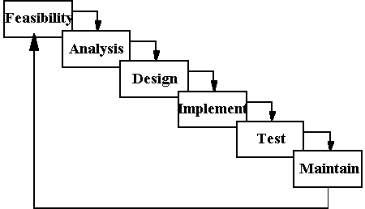

**PROBLEM ANALYSIS**

**Applications**

The main applications of the On Line Placement System is the ability of the website to properly show enroll the artists and manage information about them. The administrator has the ability to change ,modify, view and delete the various details regarding the users and arts. The users have the ability to log in and post their queries and download arts.

**Challenges**

The challenges mainly lie in detecting attacks like viruses, hacking and also in the implementation of firewall. A virus can enter the system and can disrupt the working of the website. Hacking can be done by some people who want to access some restricted sections of the website (e.g. administrator’s area) and to modify or taper some aspects of the website.

Scanning attacks may yield:

(i) The method used by viruses to enter the system.

(ii) The types of database allowed through a firewall.

(iii) The paths or ways used by hackers to enter the system

(iv) The loopholes remaining in the system (or website) which are used by attackers.

(v) The server from where the viruses or hackers are gaining access to the system.

(vi) The types of viruses able to affect the website.

And with the implementation of firewall and other security mechanisms that are designed for it, the On Line Placement System Website safe and secure.

**REQUIREMENT ANALYSIS**

**Goal of Thesis**

The goal of our thesis is to develop a website that can be used as an enrollment website with the features of interaction and problem solving. The whole project will be based on PHP with MYSQL as the database with certain security constraints added to it.

Our aim is also to implement the Administrator part in to the project so that the server or administrator himself can view, add, delete and modify.

1. **Administrator**

He has to see whether the website is working properly and whether the details available in the system are relevant and correct. He can view, add, modify, delete details.

1. **Database**

The database keeps all the records of all the users i.e. name,course, phone no.,dob, city, country,etc. For creating such records it takes the help of tables which is created in the MYSQL. The tables can have infinite entries of all the registered users as well as administrators.

1. **Clients**

Our aim will also to provide efficient way by which client can enter to see his profile, ask questions to his teacher and download softwares.

1. **Security Constraints**

There need to be certain constraints which have to be implemented on the database as well as on the administrator in order to work properly the whole system, such as declaring the primary key, or such constraints in order to keep the database work properly.

**Some of such constraints are as follows:**

**1.** Each user has a field called username which can be used to differentiate between different users.

**2.** The administrator has his own password known to no one else to access a unique page.

3. Only the administrator has the right to delete, modify users and questions.

4. Administrator has to first login to get access to myaccount part and modify some data available in the website.

5. A new user cannot have same username and password as of some already registered user.

6.When user or administrator click on logout the session of the user ends and he has to again login using his/her username and password to access the same functionality.

7. Checks are implemented so that the mandatory fields are filled by users when the user is entering some information in the system.

8. Latest firewalls and other antivirus and anti hacking modules are to be used with the website so as to protect the website from external attacks.

**FEASIBILTY STUDY**

From the inception of ideas for software system, until it is implemented and delivered to customer and even after that the system undergoes gradual developments and evaluations.

The software is said to have life cycle composed of several phases.

At the feasibility stage, it is desirable that two or three different configuration will be pursed that satisfy the key technical requirement but which represent different level of ambition and cost.

Feasibility is the determination of whether or not a project is worth doing. A feasibility study is carried out select a best system that mate performance requirements.

The data collected during primary investigation examines system feasibilities that is likelihood that the system will be beneficial to the organization. Four tests for feasibility study are as follows:-

* **Technical Feasibility:** This is concerned with specifying equipment and software that w ill successfully satisfy the use considerably, but might include
  + The feasibility to produce output in a given time because system is fast enough to handle multiple users.
  + Response time under certain circumstances and ability to process a certain volume of transaction of a particular speed.
  + Feasibility to communicate data to distant location.
* **Economical Feasibility:** Economic analysis is the most frequently used technique used for evaluating the effectiveness of a proposed system. More commonly known as cost/benefit analysis the procedure is to determine the benefits and savings that are expected from a proposed system and compared them with cost. Though the cost of installing the system may appear high, it is one time investment. The resulting benefits is that automation results in turnaround time. The resulting cost/benefit ratio is favorable.
* **Operational Feasibility:** It is mainly related to human organizational as social aspects. The points to be considered are - The system interface is standard, user friendly and provides extensive help. Hence no special training is not required.
* **Social Feasibility:** Social feasibility is determination of whether a proposed project will be acceptable to people or not, So this project is totally Social and Feasible

**SYSTEM ANALYSIS**

The Analysis model:

The analysis model must achieve three primary objectives:

* To describe what the customer requires.
* To establish the basis for the enhancement of a software design.
* To define a set of requirements that can be validated once the software is completely enhanced. The main elements of the analysis model are briefly described below.
* At the core of the model lies the ***data dictionary***, which is a repository that contains descriptions of all the data objects consumed or produced by the software .Three different diagrams surround the core.
* The **entity relation diagram** depicts relationships between data objects.
* The **data flow diagram** provides an indication of how the data is transformed as they move through the system.
* The **state transition diagram** indicates how the system behaves as a consequence of external events.

**DESIGN PHASE**

The design phase involves converting the informational, functional, and network requirements identified during the initiation and planning phases into unified design specifications that developers use to script programs during the development phase. Program designs are constructed in various ways. Using a top-down approach, designers first identify and link major program components and interfaces, then expand design layouts as they identify and link smaller subsystems and connections. Using a bottom-up approach, designers first identify and link minor program components and interfaces, then expand design layouts as they identify and link larger systems and connections.  
Contemporary design techniques often use prototyping tools that build mock-up designs of items such as application screens, database layouts, and system architectures. End users, designers, developers, database managers, and network administrators should review and refine the prototyped designs in an iterative process until they agree on an acceptable design.

Designers should carefully document completed designs. Detailed documentation enhances a programmer’s ability to develop programs and modify them after they are placed in production. The documentation also helps management ensure final programs are consistent with original goals and specifications. Organizations should create initial testing, conversion, implementation, and training plans during the design phase. Additionally, they should draft user, operator, and maintenance manuals.

For design of the website project:

1. First Database has to be designed which can be used to handle all the requirements of the users.
2. The basic structure of the website has to be designed.
3. The main template to be used for the website is designed.

**DFD Symbols**

* A square defines a source of destination or system data.
* An arrow line identifies the data flow or data in motion. It is a pipeline through which information flows.

* A circle or bubble represents a process transform incoming data flow in to outgoing data flow.
* A horizontal line represents data stored or data at rest or a temporary rest repository of data.
* An open rectangle refers to the database storage

**Admin Panel:**

**Admin**

**Site**

**Login** 1.1

**Manages** menu

**View Member**

1.2

tbusr

tbmem

Admin is the administrator of the site. He manages the site and can view members after login. And also add ,delete ,modify menu

**User Panel:**

**Member**

**Login** 1.2

**Register** 1.1

**Request for special dish**

**Site**

**View menus like**

**Tandoori**

View dish

A new member needs to be registered to login and registered member can login directly by its login username and password. Once logged in, he/she can view details of menus ***DATA FLOW DIAGRAM OF***

  

var args = [0, 1, 2];

f(...args);







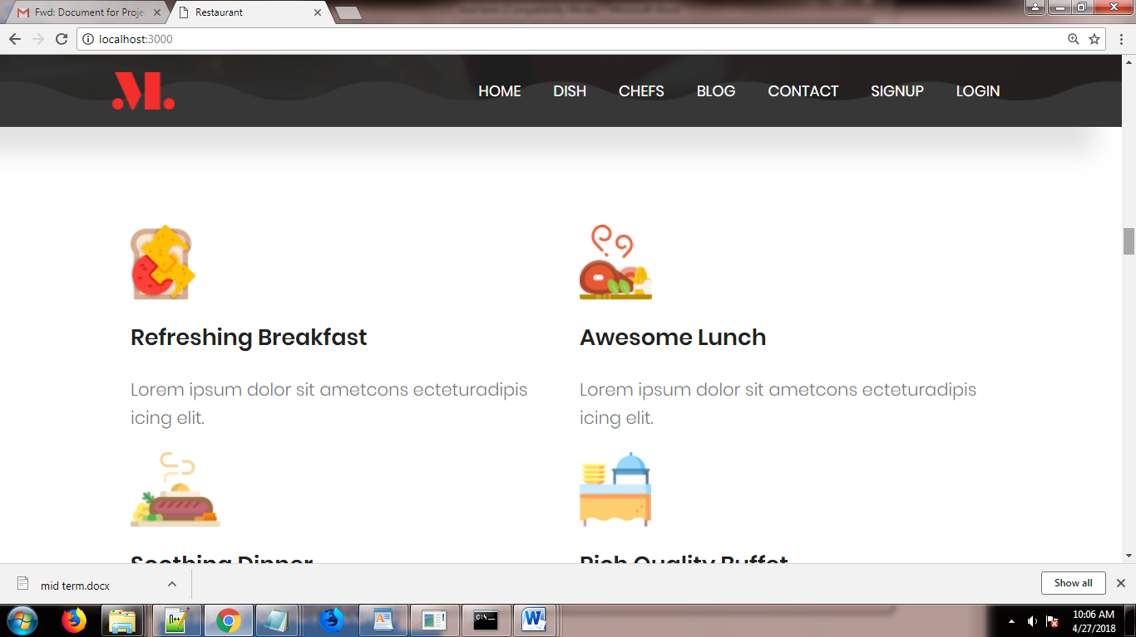

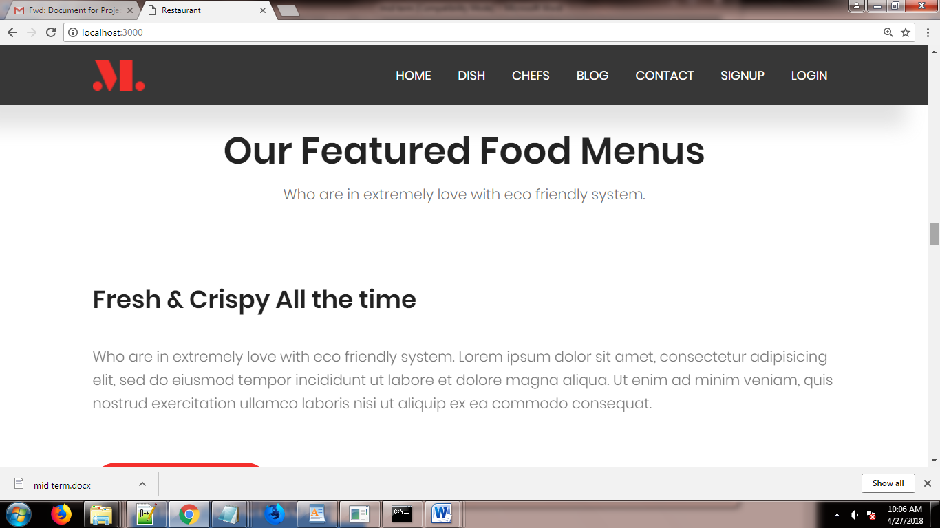





 

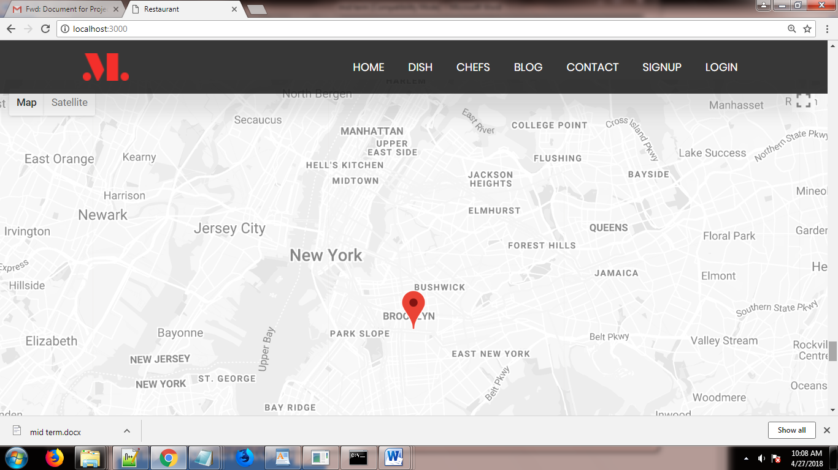

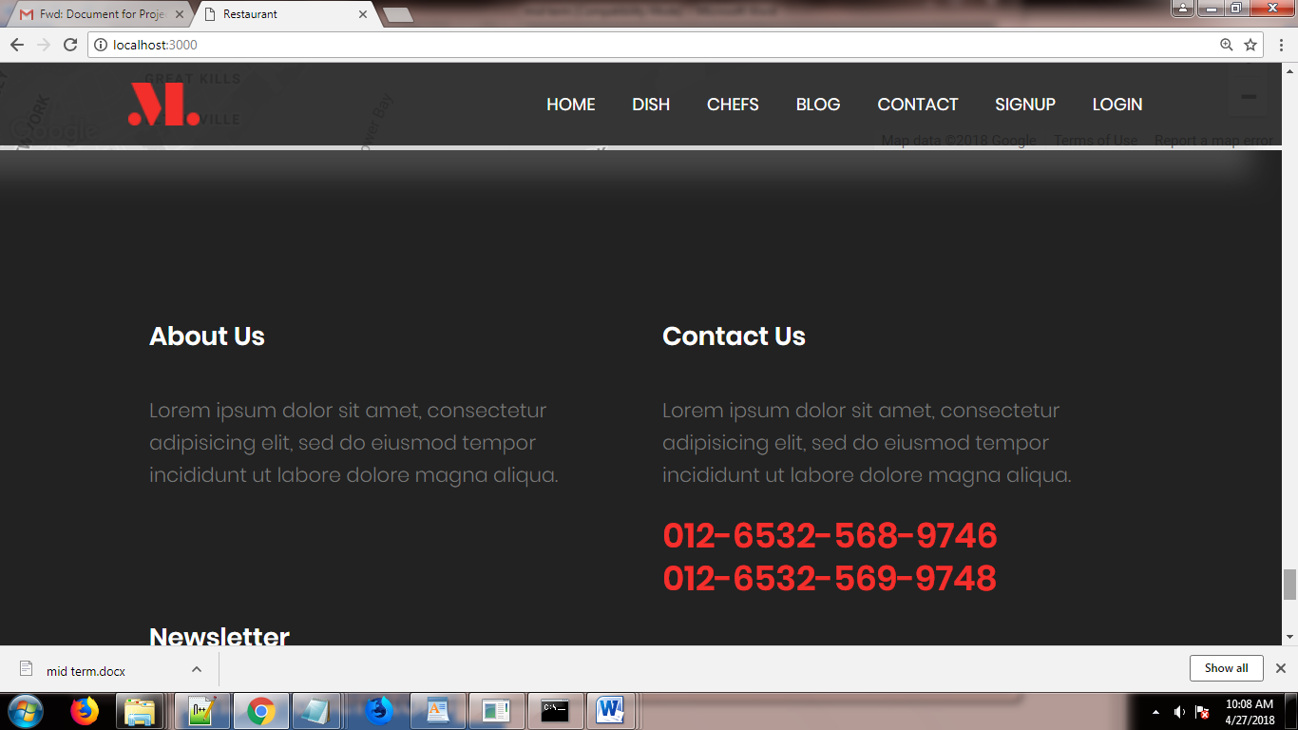

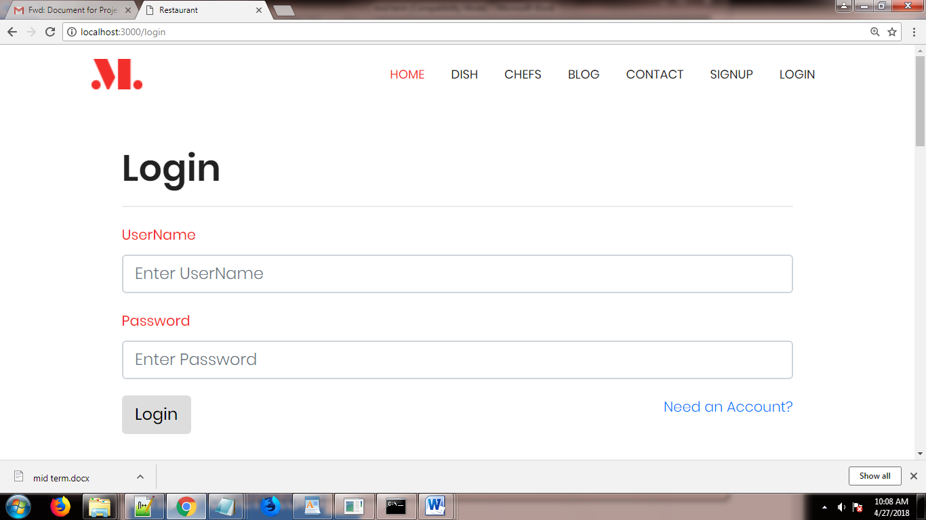

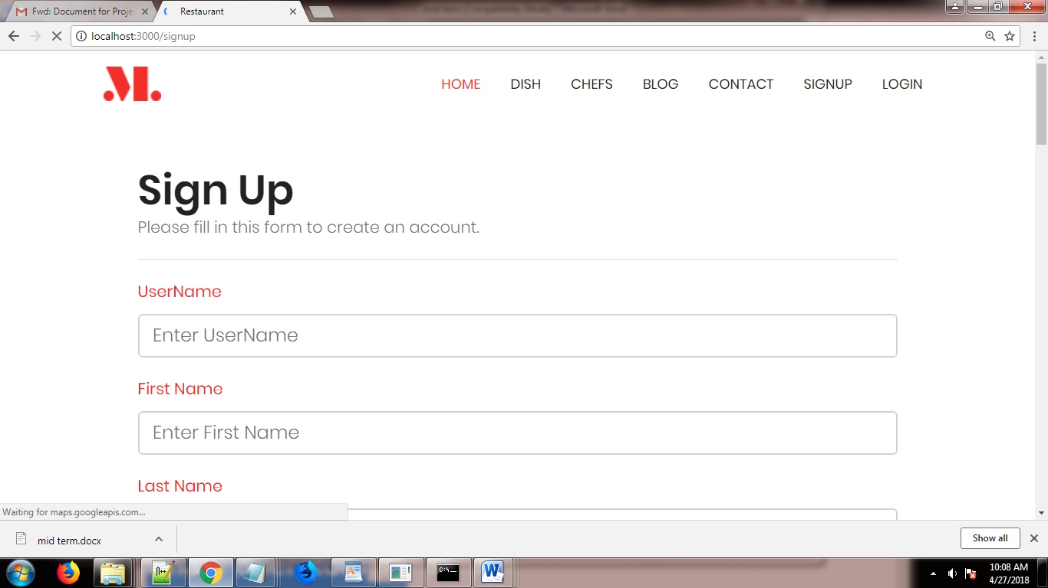

Admin Home page

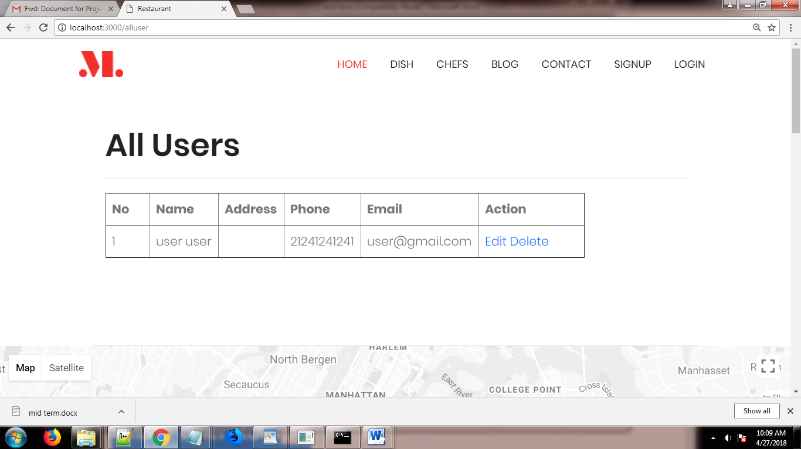

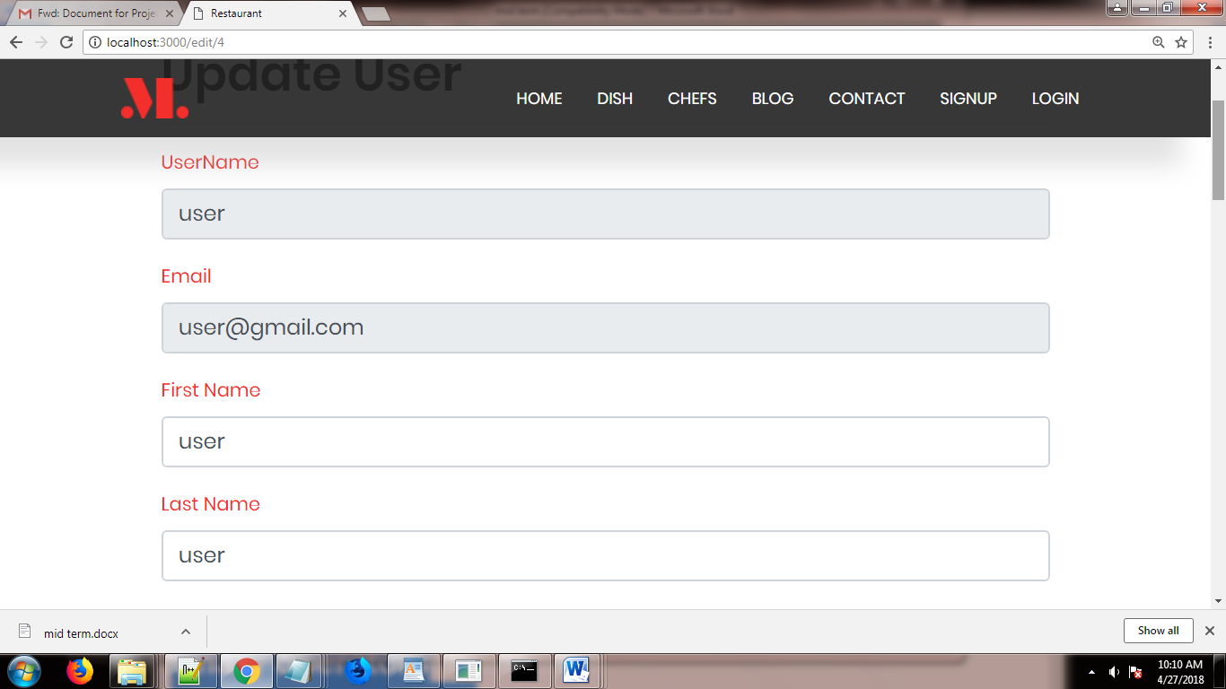

AddMenu

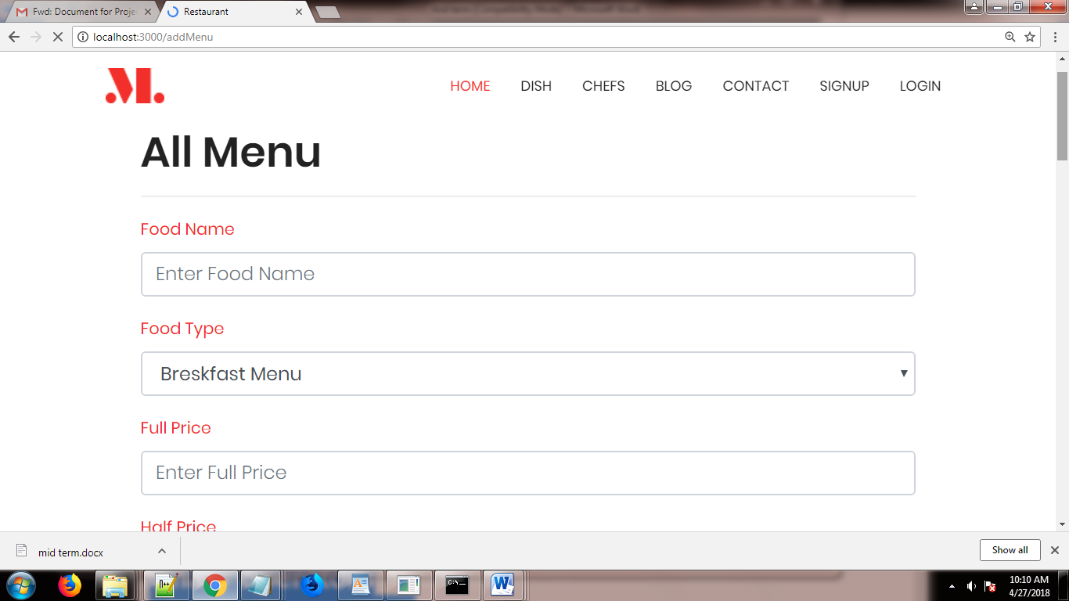

User Home page

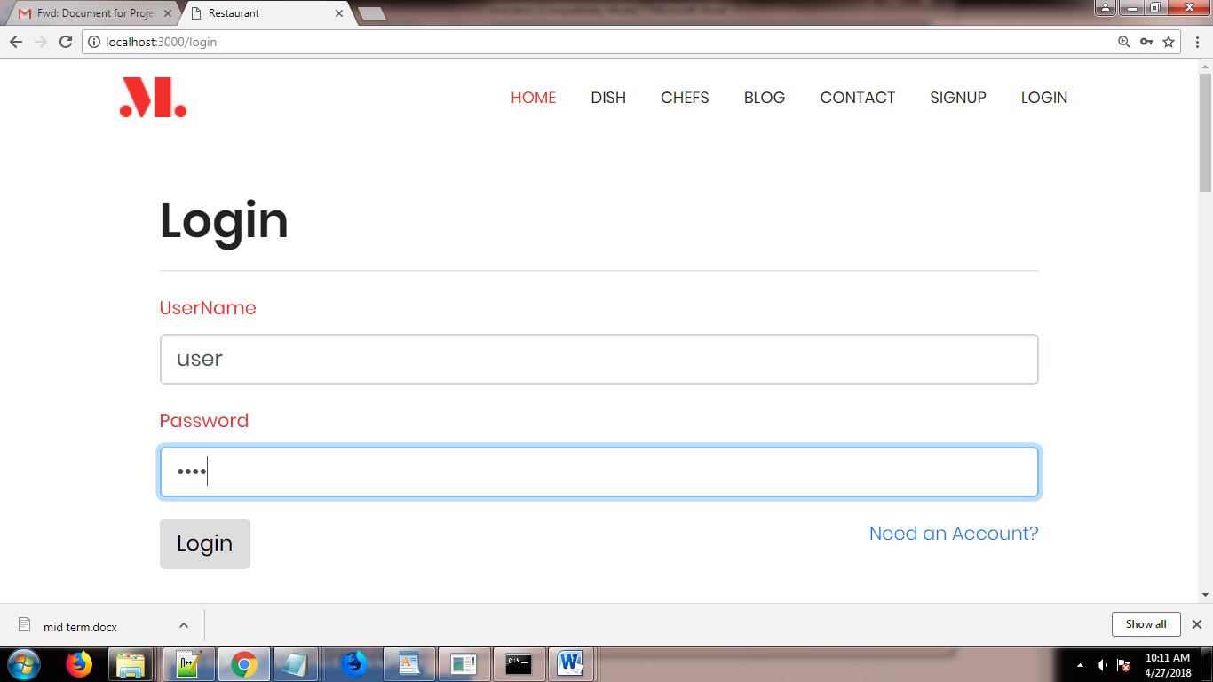

Use Home page

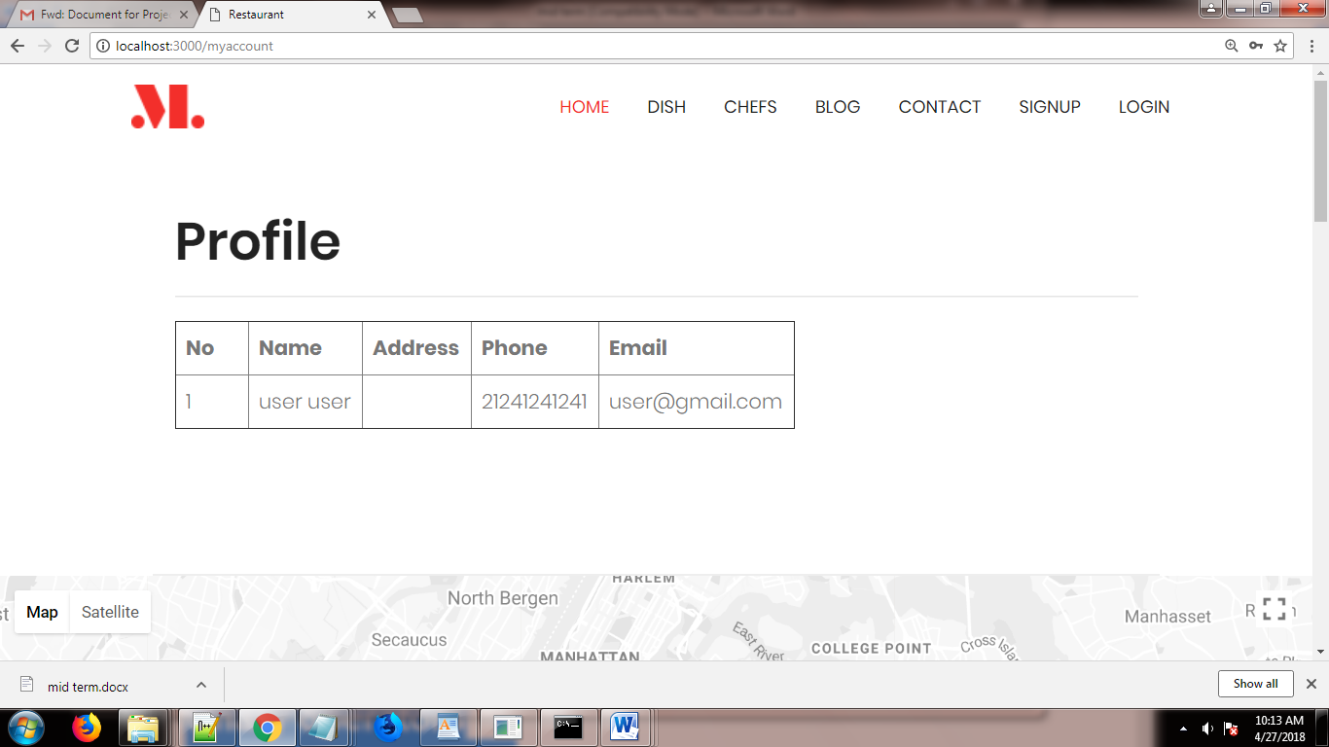

Check Menu

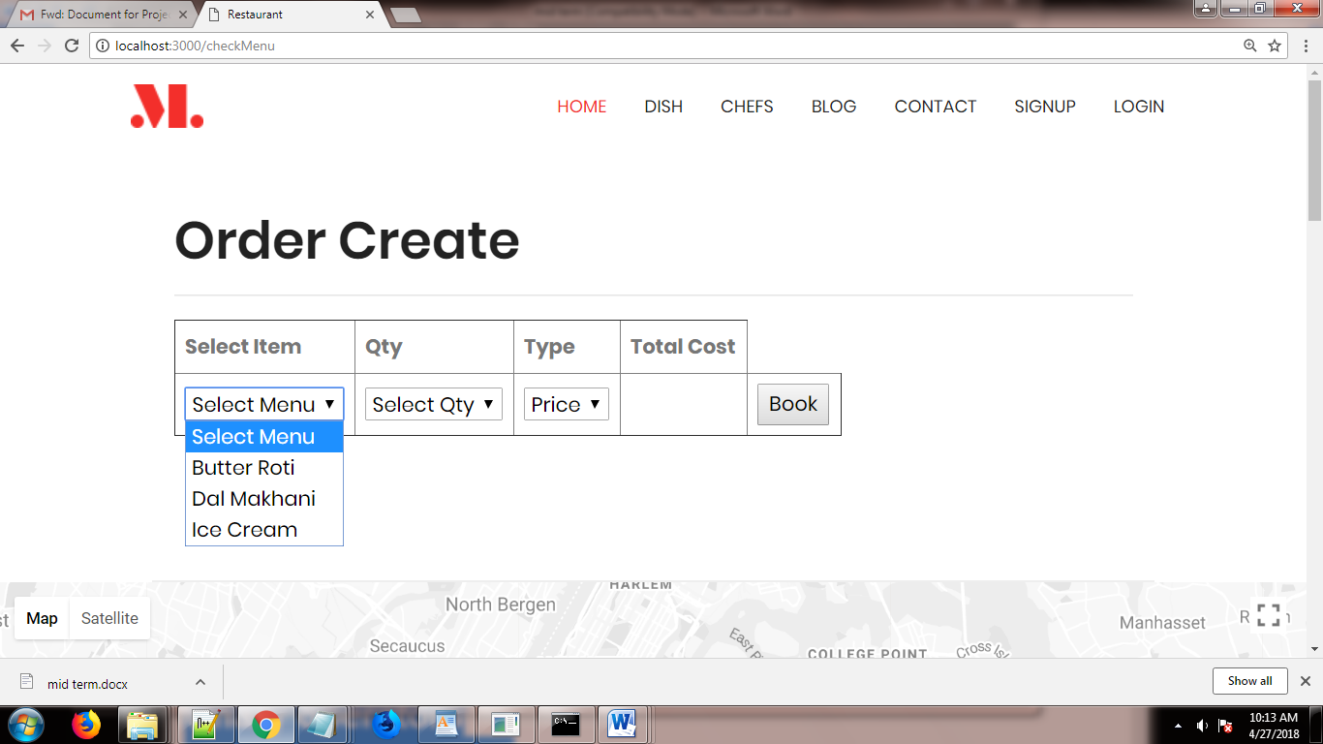

BookMenu

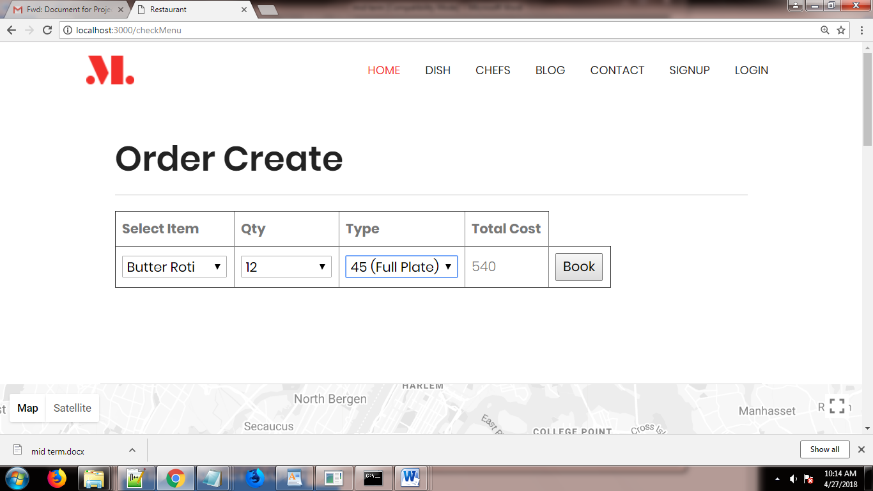

After Booking

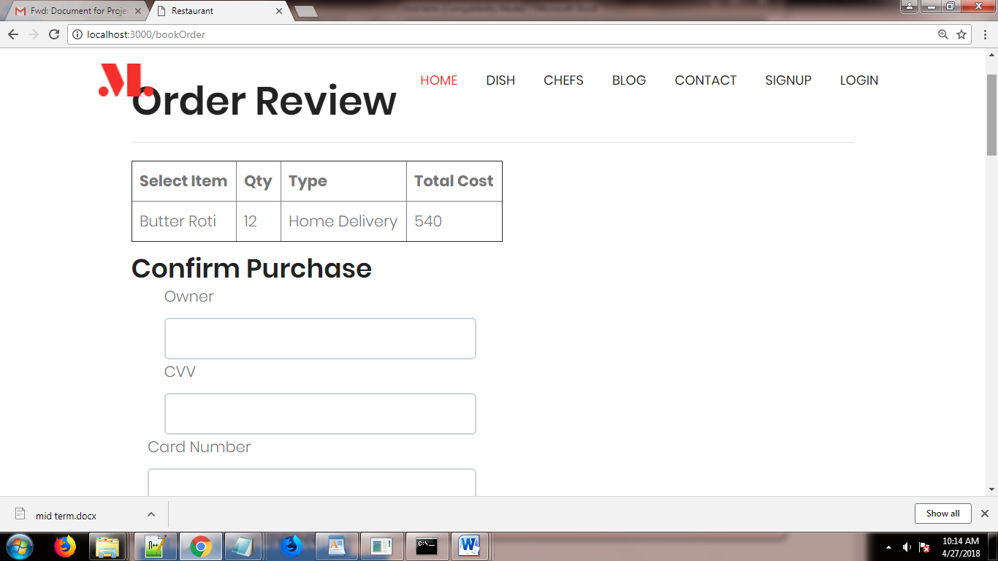

Order Confir mation

